**Estimate The Presence of Impurities in Iron Ore Using IBM Watson Machine Learning**

1. **INTRODUCTION**
   1. **Overview**

Iron ores are rocks and minerals from which metallic iron can be economically extracted. Iron is usually found in the form of Magnetite, Hematite, Goethite, Limonite, or Siderite.  Usually, Magnetite Iron ore concentrate contains an impurity of 3–7% of silica. Estimation of silica involves a lot of chemical analysis which is time-consuming and involves high operational cost. In order to cut down the operational cost and also to help engineers by predicting at a faster rate, we make use of  Machine Learning (ML). So the main goal of this project is to build a Machine Learning model to predict the impurities present in an Iron ore.

* 1. **Purpose**

Iron is usually found in the form of so many minerals.  Usually, Magnetite Iron ore concentrate contains an impurity of silica. Estimation of silica by the engineers involves a lot of chemical analysis which is time-taking process and involves high operational cost. In order to decrease those operational cost and also to help engineers by predicting at a faster rate, we make use of machine learning.

1. **Literature Survey**
   1. **EXISTING PROBLEM**

* Estimating of silica from the concentrate iron ore is very difficult.
* Engineers need to do lots of chemical analysis for estimate the impurities from the iron ore.
* For this analysis process it would take so much time.
* For performing all these analysis processes, it might increase the operational cost.
  1. **Proposed solutions**
* The proposed solution for the problem is first we need to collect the data related to the data mining to estimate the impurities percent present in it.
* According to the collected data we perform different actions for getting the best accuracy for predicting impurities in iron ore.
* The use of this method may increase the accuracy and decrease the operational cost for performing different chemical analysis.

1. **THEORETICAL ANALYSIS**

**3.1 BLOCK DIAGRAM**

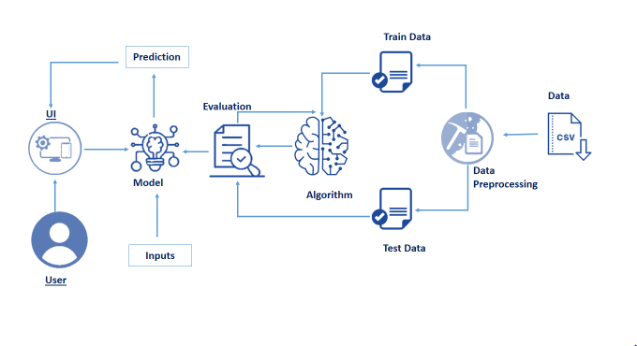

**3.2 hardware /software designing**

**Software requirements:**

* OS – Windows XP,7,8,9,10
* Jupyter Software
* Syder Software
* Anaconda Prompt

**Hardware requirements:**

* Processor – i3 (min)
* Hard Disk Storage - 10 GB
* RAM – 1 GB

**4.EXPERIMENTAL INVESTIGATION**

In our project, we collected information i.e., inputs required for the estimation of impurities present in the considered iron ore. In our task we collect parameters like silica feed, iron feed, starch Flow, Amina Flow, air Floatation columns and flow, pH, Density of ore pulp etc., for estimating the impurities percentage present in the iron ore. By considering these parameters and applying machine learning in python.

  We have built a web application that is integrated to the model we built. A UI is provided for the users where he has to enter the values for predictions. The enter values are given to the saved model and prediction is showcased on the UI.

These are following steps

* Built HTML Pages
* Built server-side script
* Imported Flask module

By calculating all the parameters present in the given dataset, The output is displayed as the iron concentrate and silica concentrate separately.

1. **Flow Chart:**

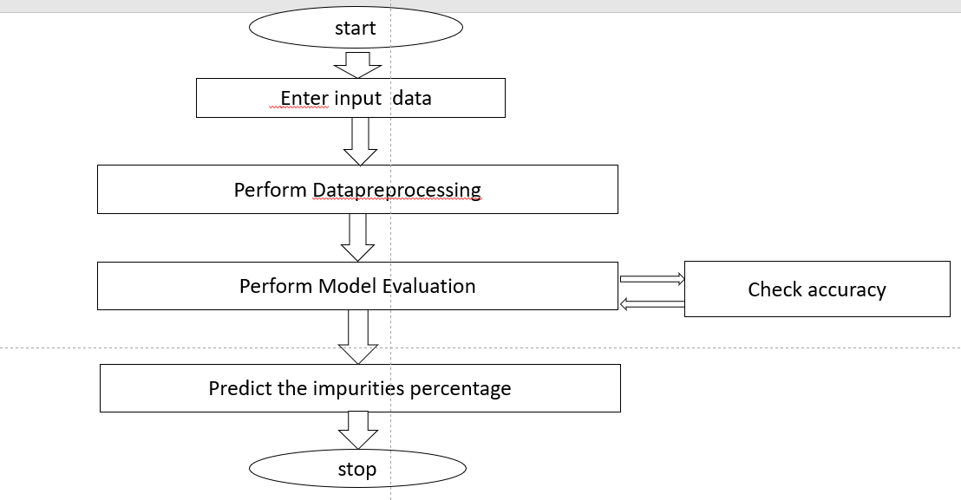

**6. Result:-**

**Here the result is showed in just 3 steps, They are:**

* The user interacts with the UI (User Interface) to enter the data about their iron ore.
* Entered data is analyzed by the model which is integrated.
* Once the model analyses the input, the prediction is showcased on the UI.

**7. ADVANTAGES AND DISADVANTAGES: -**

**ADVANTAGES:**

* **Accurate predictions-**

Estimating of impurities(silica) from the iron ore should be accurate.

* **Easy usage-**

By only entering the data of iron ore ,it will calculate impurity(silica) percentage directly and display the percentage of both pure ore and silica percentage.

* **Less Operational cost-**

Generally iron ore contains lots of other minerals too, along with impurities(silica). Engineers will apply so many chemical analysis for estimating the impurities present in it, which may leads to increase the operational cost. Through our project cost will be minimized.

* **Faster-**

By Skipping all the chemical analysis processes for estimating the silica percentage in iron ore, It will definitely reduce our time.

**DISADVANTAGES:**

* For the estimation we need many inputs and sometimes it may lead to some uncertainty in the data or there might be any missing values which need to be taken care about.

**8. APPLICATIONS**

* Estimating the impurities present in the iron ore.

**9. Conclusion**

For any iron ore, lacking of impurities(silica), is the key factor to know its purity. And this model which helps in estimating impurities present in the iron ore quickly and reduce the operational cost.

**10. Future Scope**

This system can be further extended by adding new methodologies and different techniques and made it available to all those who are interested to learn.

**11.Bibliography**

<https://pubs.acs.org/doi/10.1021/ja01962a009>

<https://www.sciencedirect.com/science/article/abs/pii/0003267061802006#aep-abstract-id4>

**12. Appendix**

**a.Source code**

**App.py**

import pickle

app = Flask(__name__)

model= pickle.load(open('mining.pkl','rb'))

@app.route('/')

def home():

return render_template('index.html')

@app.route('/about')

def about():

return render_template("about.html")

@app.route('/y_predict',methods=['POST'])

def y_predict():

'''

For rendering results on HTML GUI

'''

x_test = [[x for x in request.form.values()]]

prediction = model.predict(x_test)

pred=prediction[0]

print(prediction)

return render_template('index.html', prediction_text='Predicted Quality:{}'.format(pred))

if __name__ == "__main__":

app.run(debug=True)

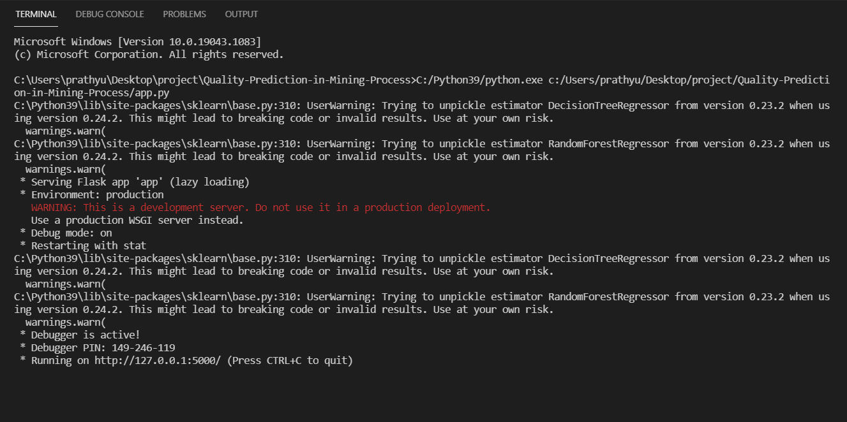

**b. UI output Screenshot**

